**Designing an IP (intellectual property) core for 32 bit multiplier, by using Vivado and PYNQ Z2 board.**

**Step-1:** open vivado tool.

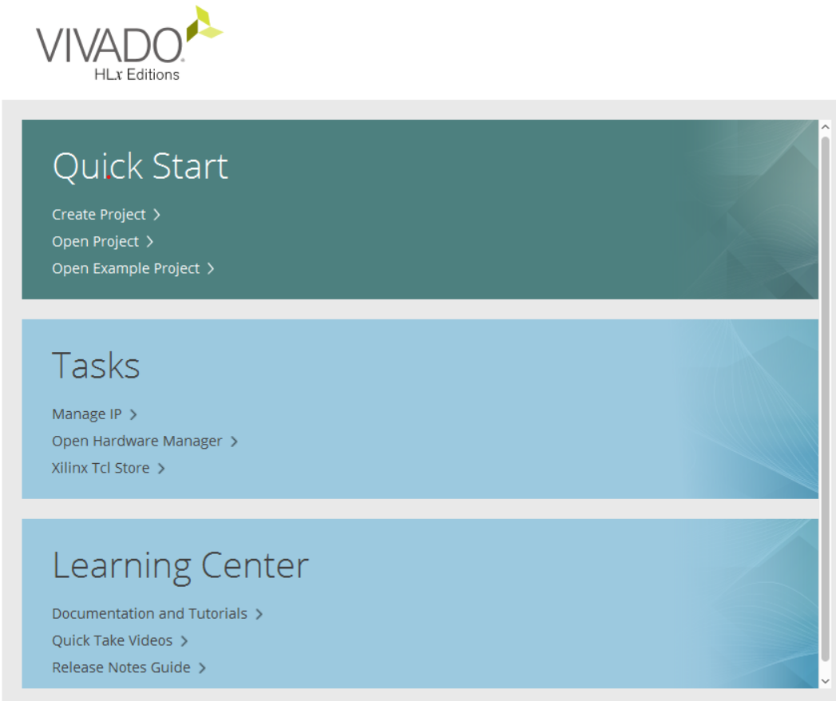

**Step-2:** Click on create project for creating a new project, click next.

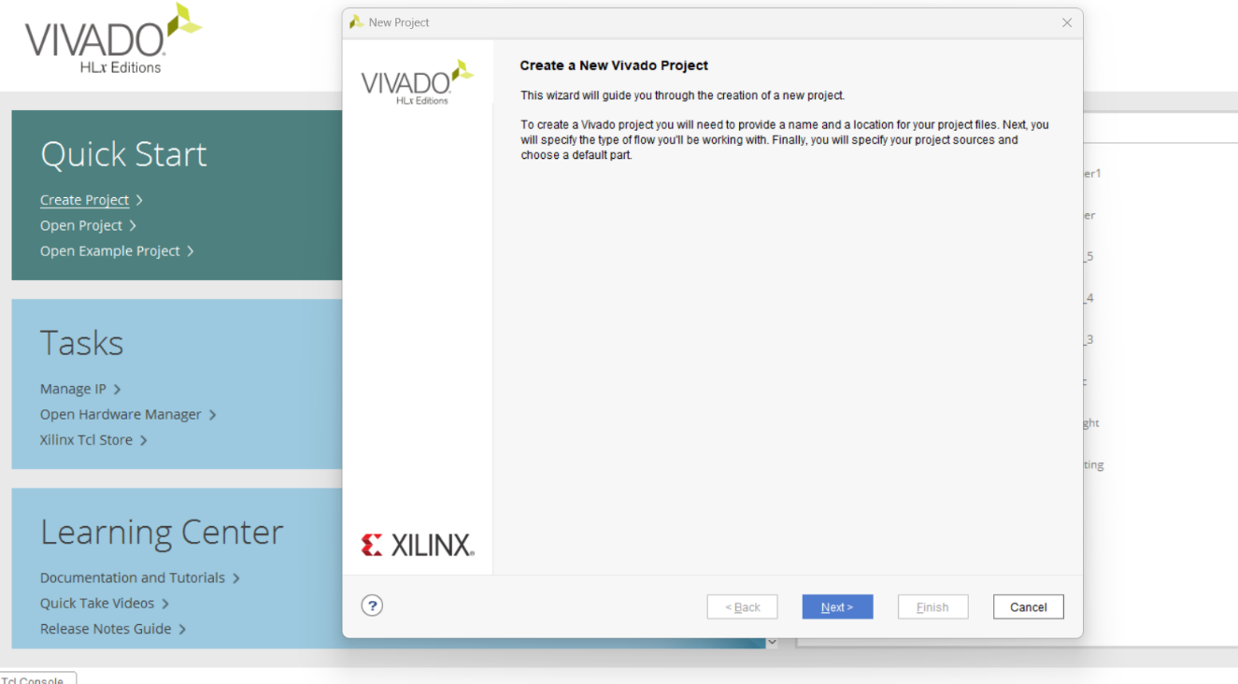

**Step-3:** Give a project name and select the project location then click next.

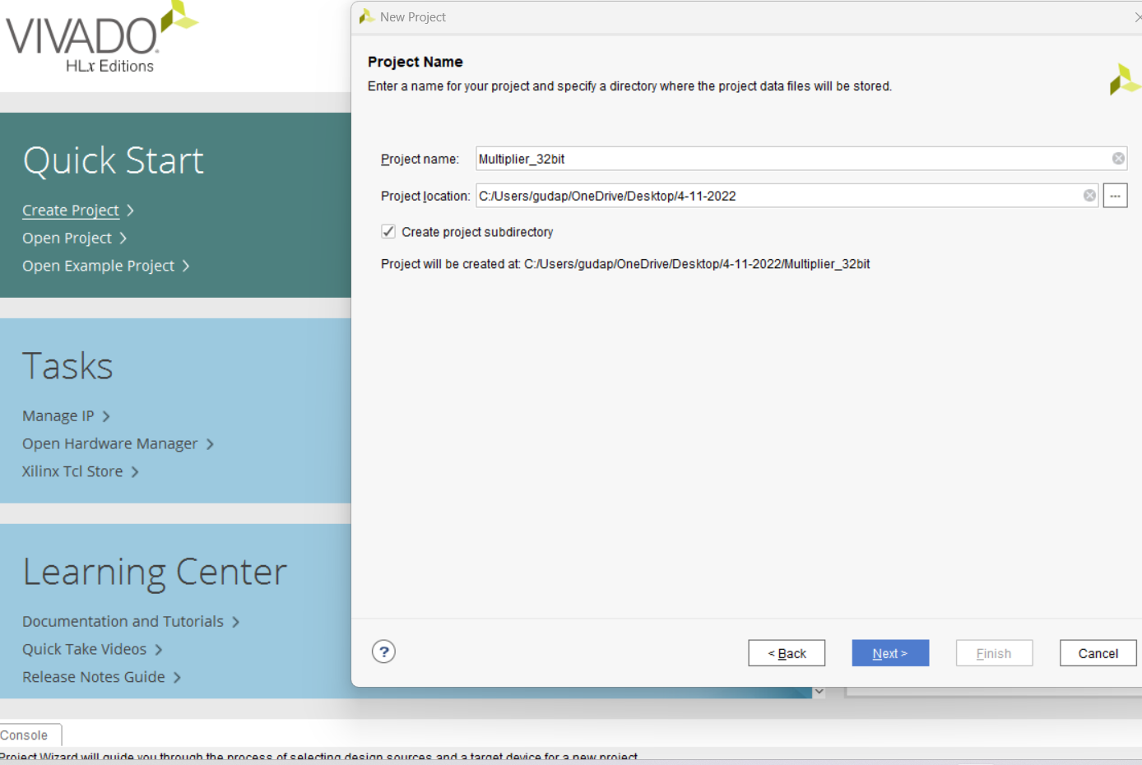

**Step-4:** Now select RTL project, because we are doing IP core design, and then click next.

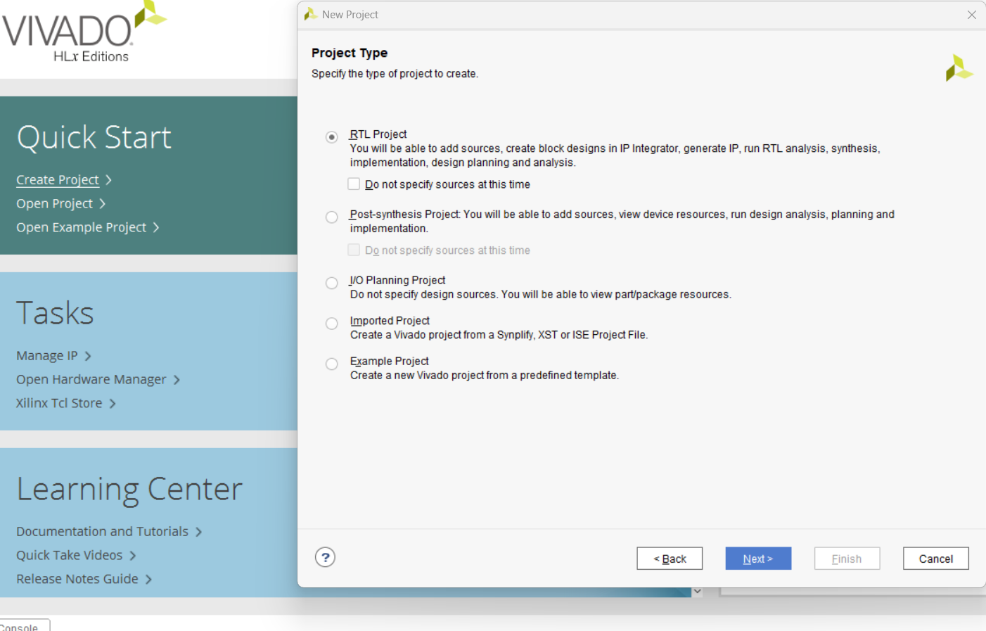

**Step-5:** we can create a design file here but I didn’t create a file here so click next.

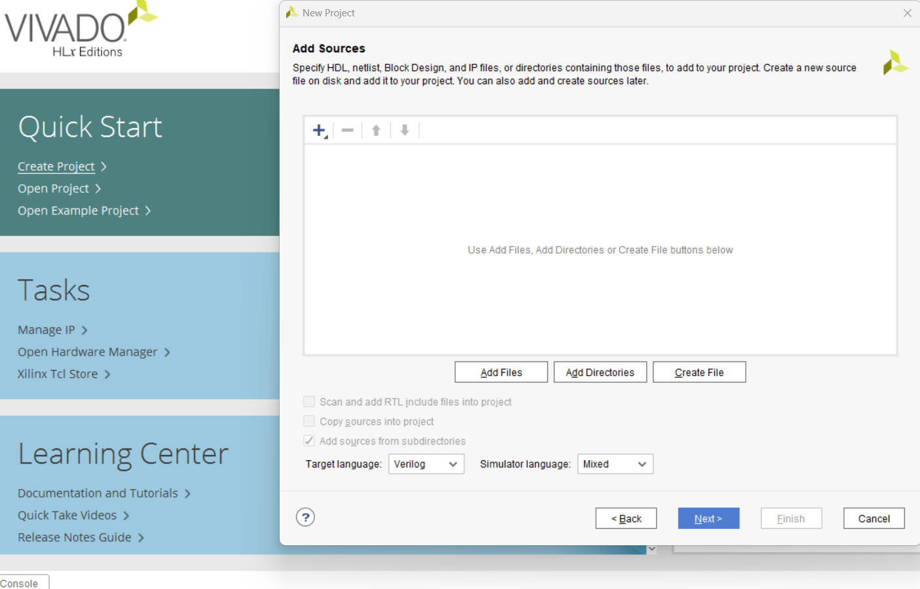

**Step-6:** Here also I didn’t add any constraint sources so click next.

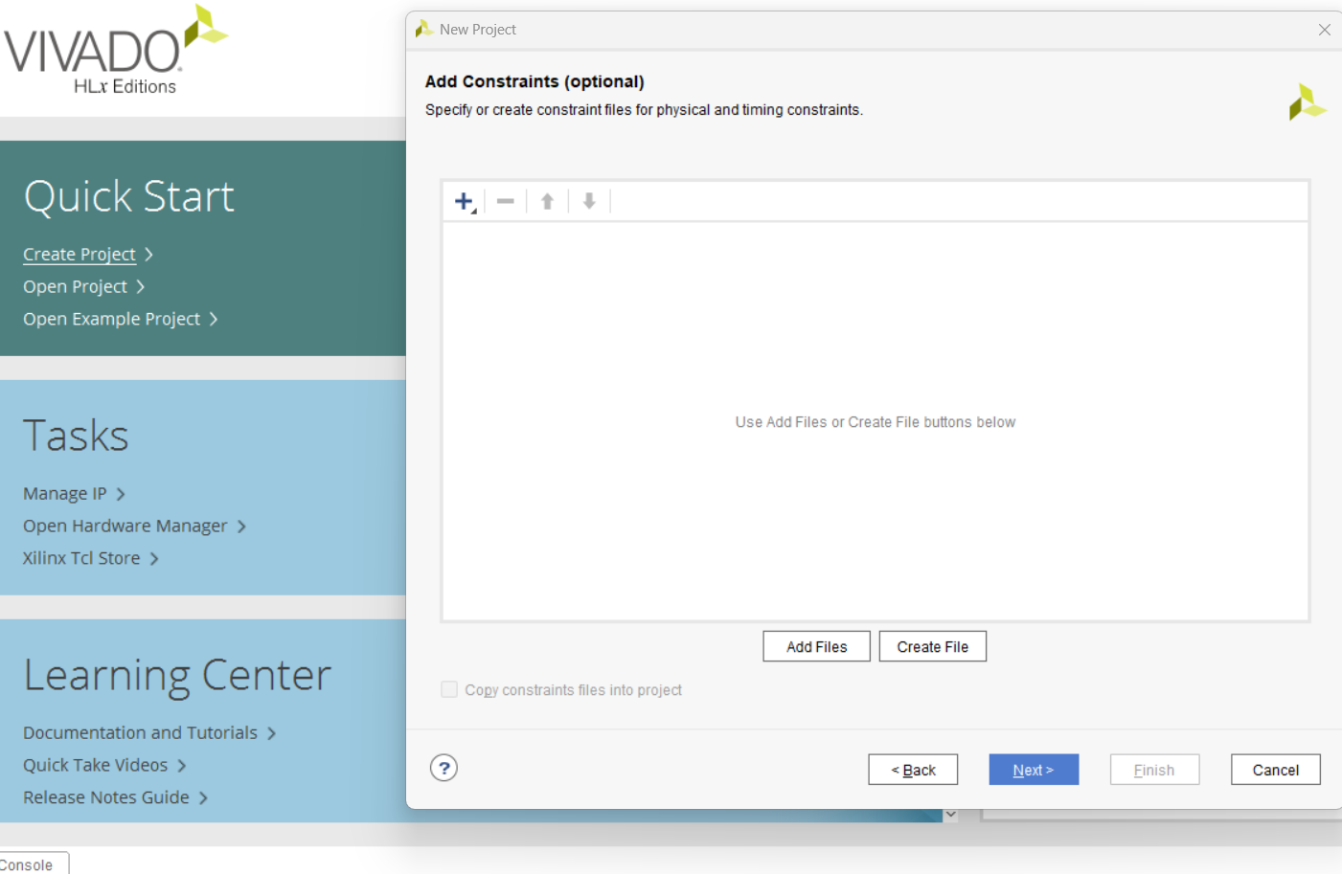

**Step-7:** Here select the part of the board which we use, I’m using a board PYNQ-Z2 so the part code is **xc7z020clg400-1.** then click next.

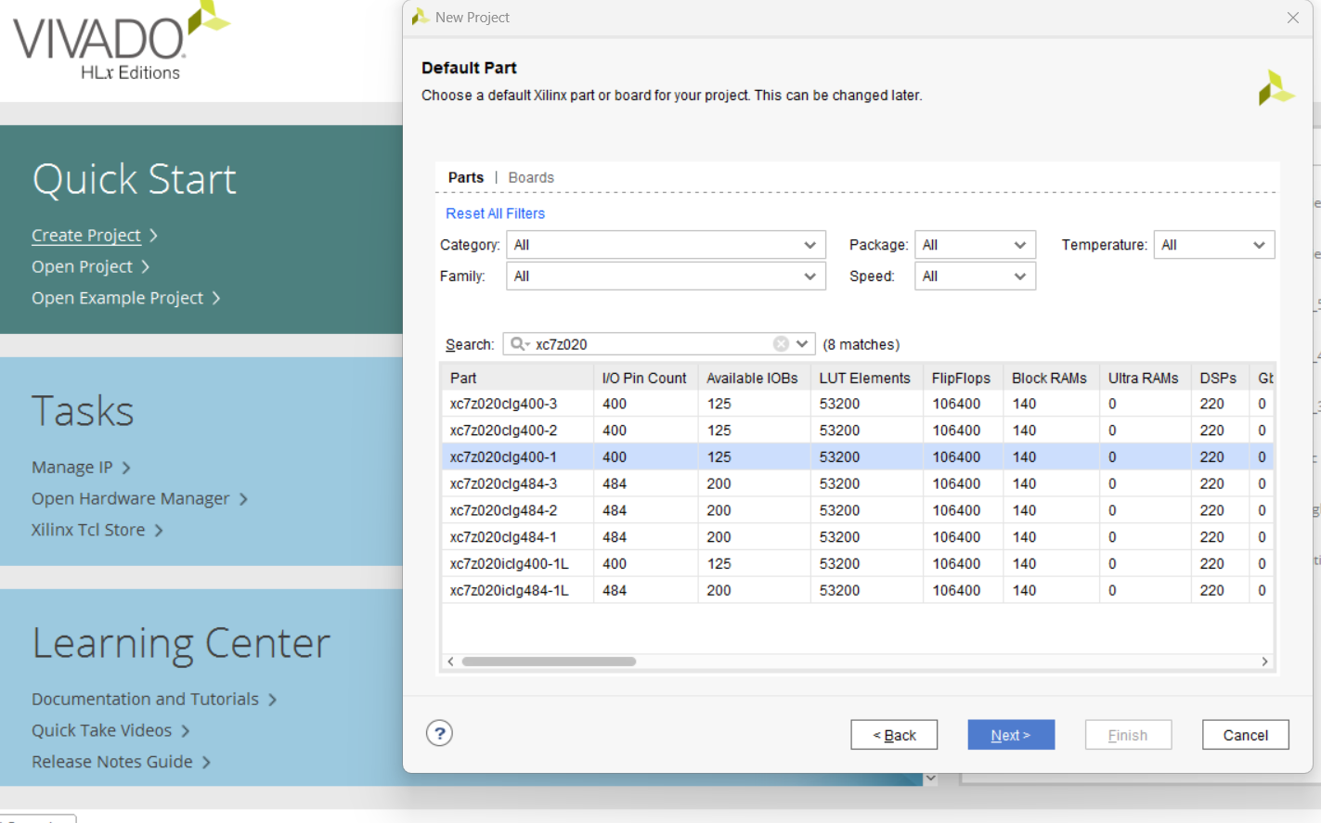

**Step-8:** Click Finish

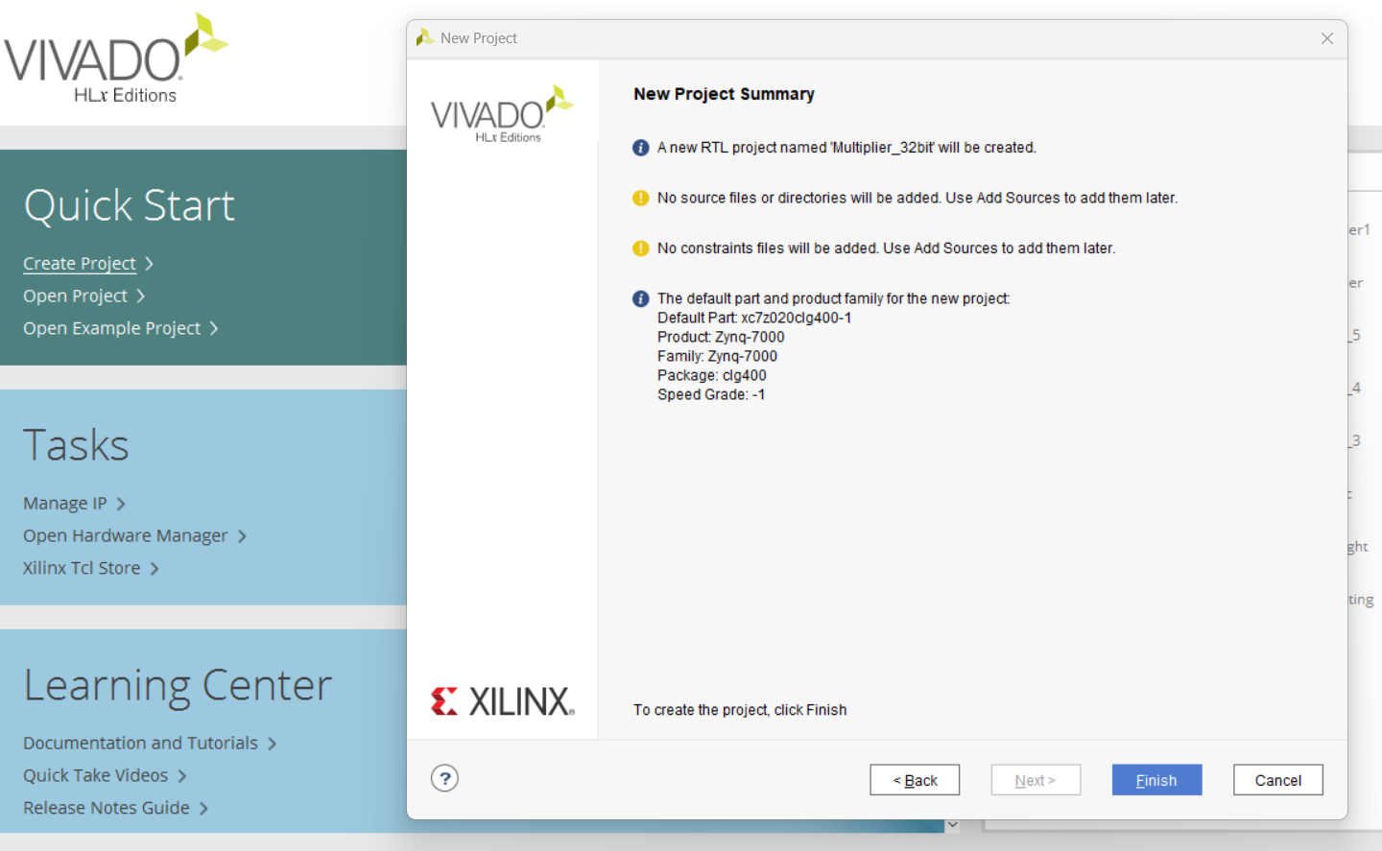

**Step-9:** After creating the project the work directory is looks like this.

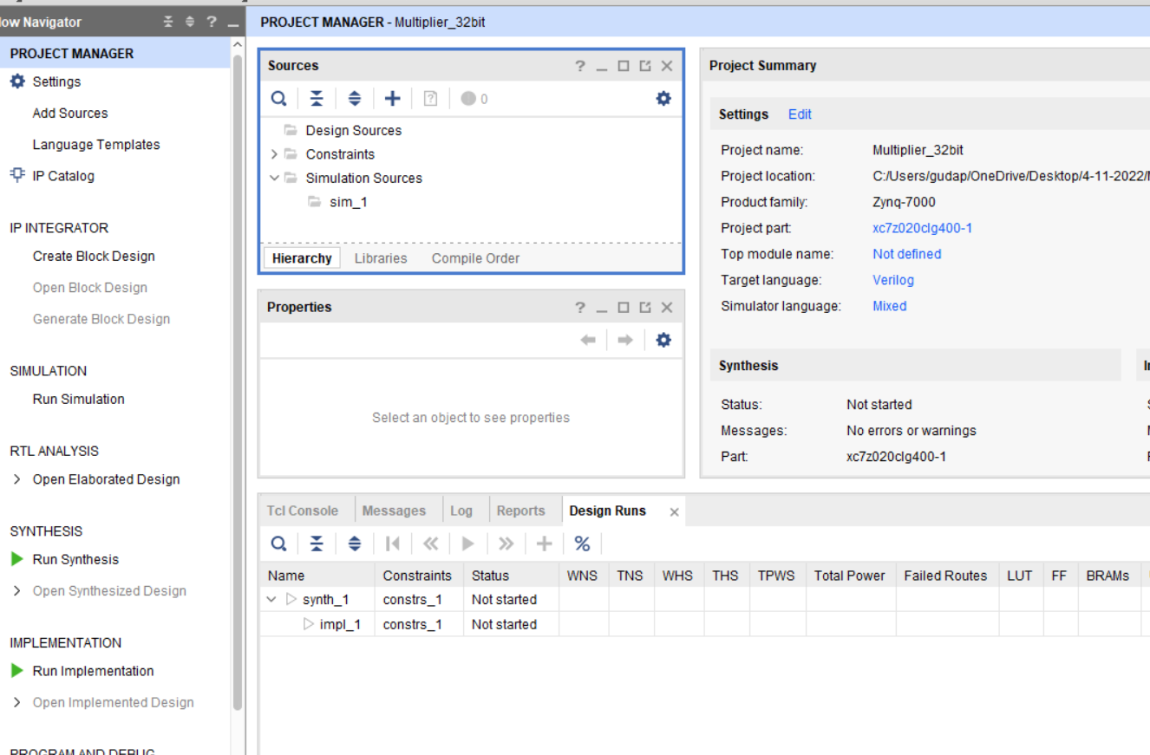

**Step-10:** Here we have seen sources, Right click on design source , click add sources.

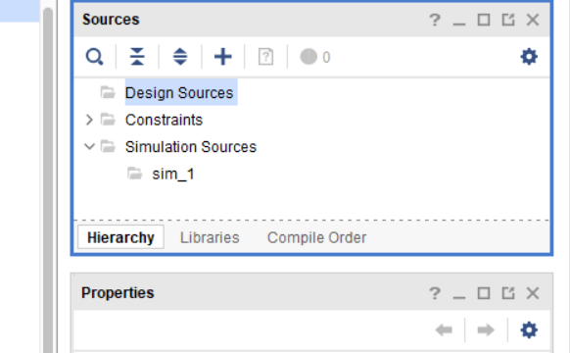

**Step-11:** select the Add or create design sources and then click next.

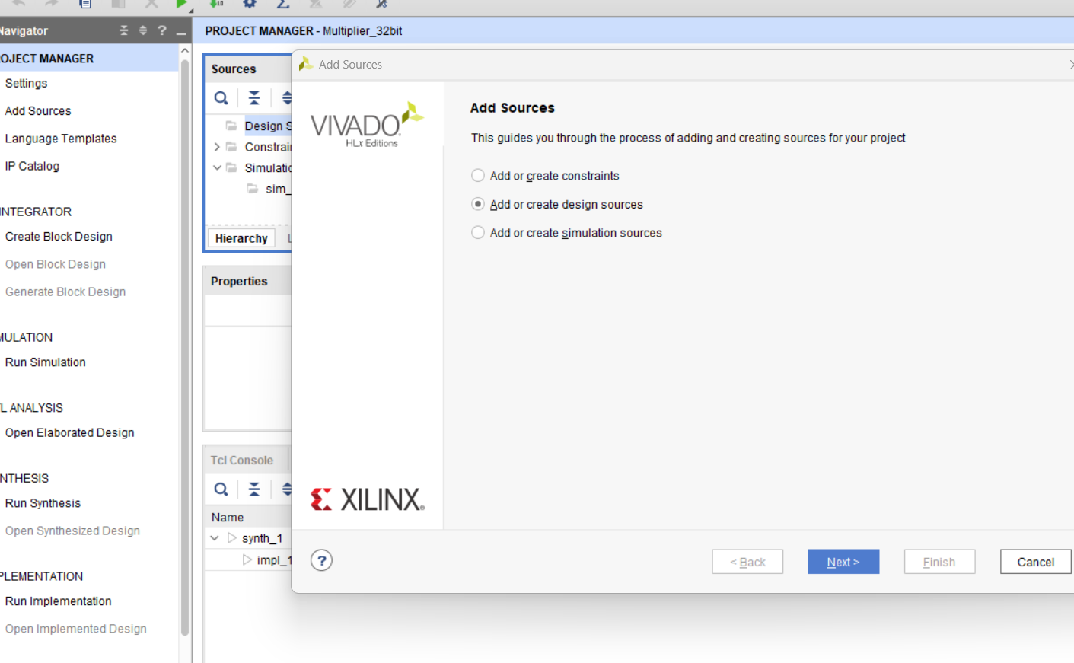

**Step-12:** click on create file.

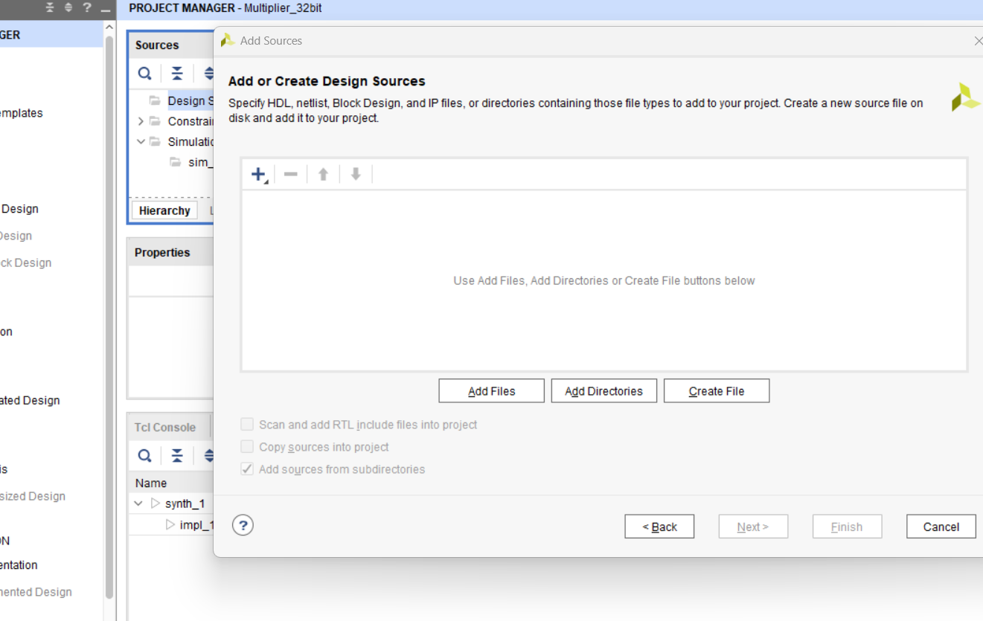

**Step-13:** GIVE the file name and choose the location then click ok and click Finish.

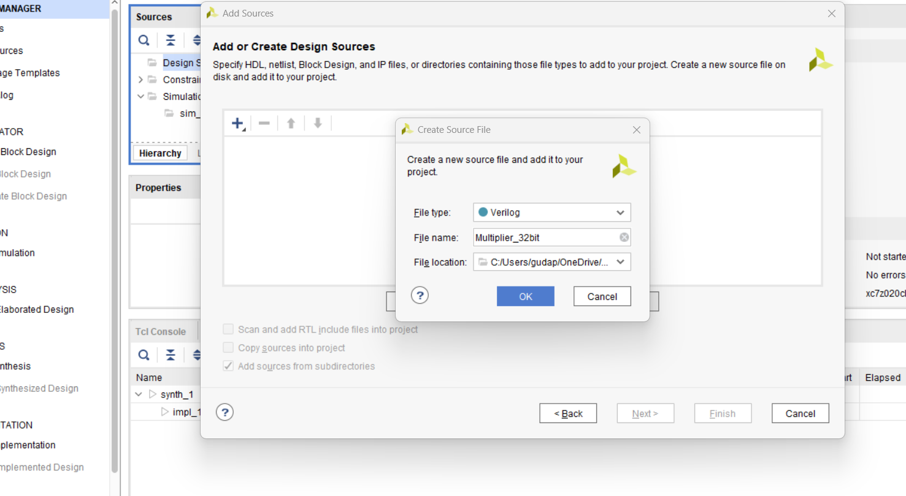

**Step-14**: click ok and Yes.

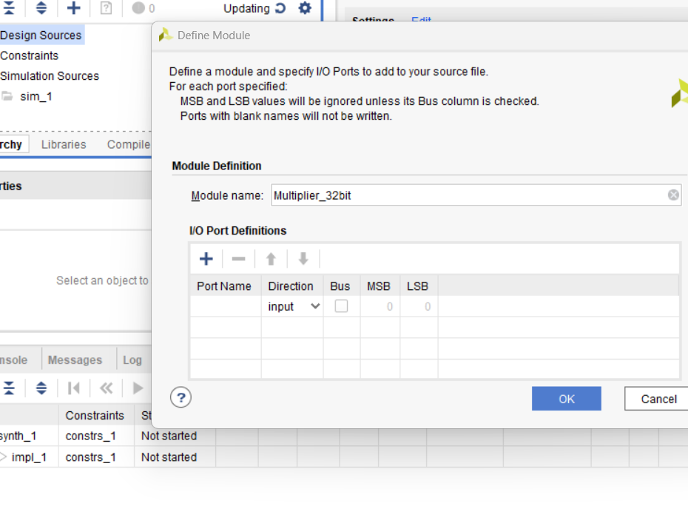

**Step-15:** Now design block is created now right click on Multiplier_32bit , click open file.

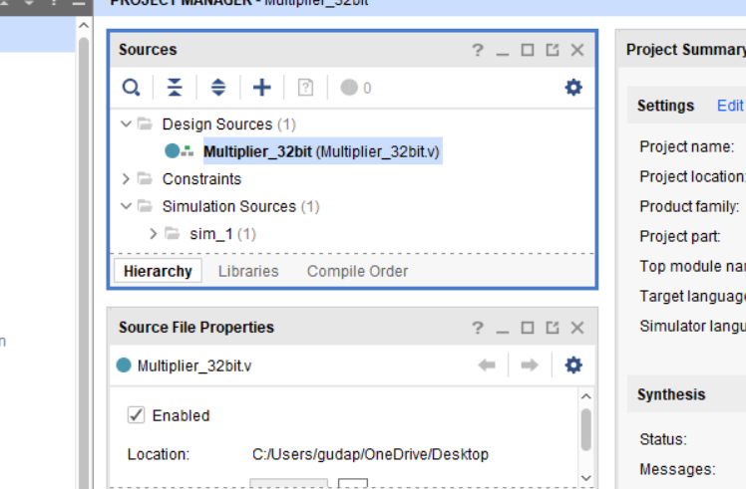

**Step-16:** Now design block is open on rightside of workspace, write the simple code for 32-bit multiplier. And then save it.

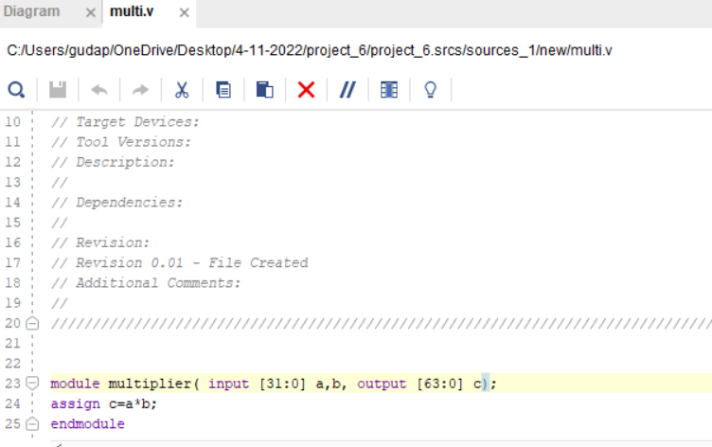

**Step-17**: Left side of the workspace in project manager window we have seen IP INTEGRATOR click on create block design, give design name and choose directory then click ok.

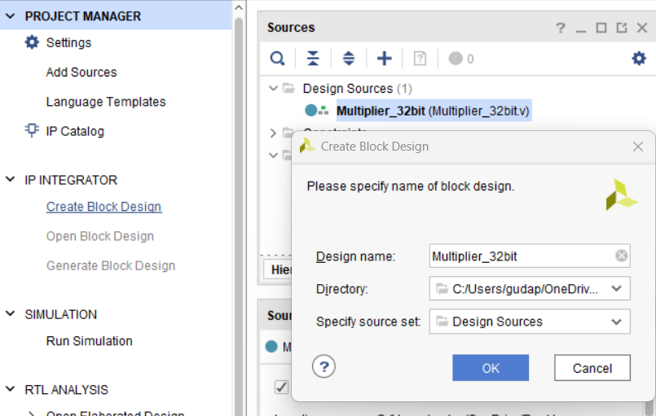

**Step-18**: design block is open.

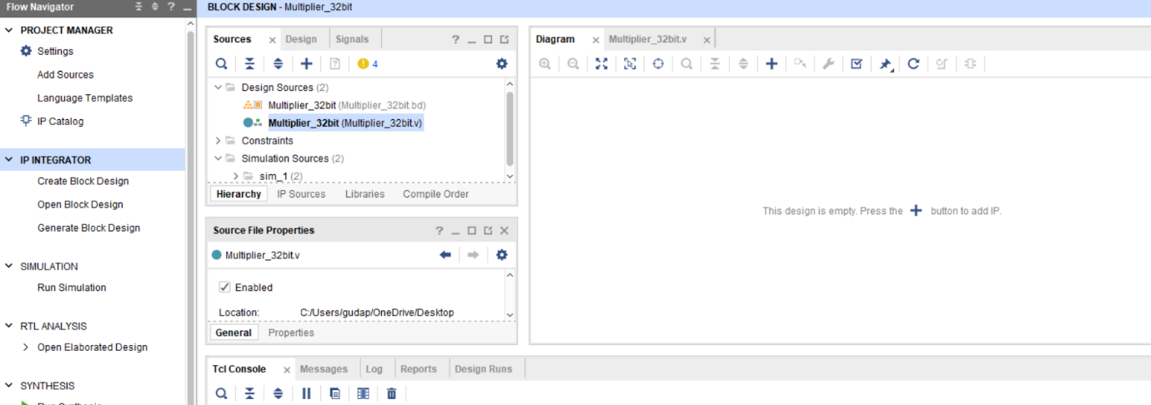

**Step-19:** Right click on Multiplier_32bit design and click on Add module to block design, so module is added.

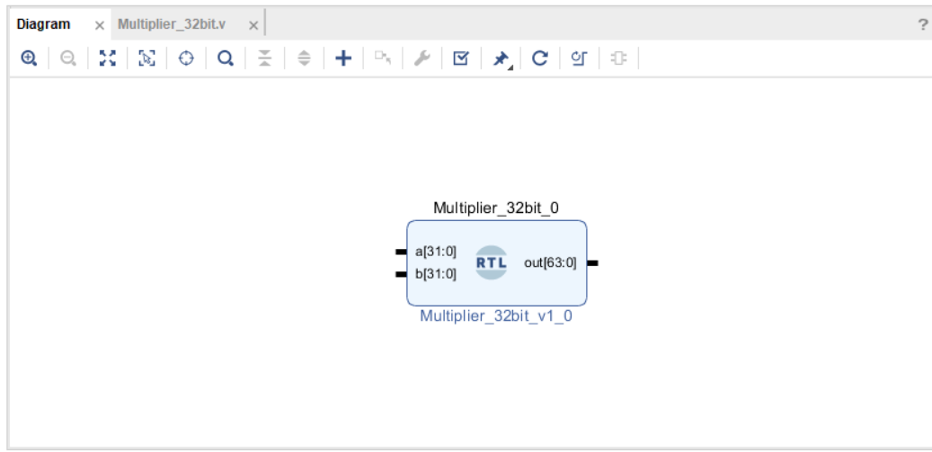

**Step-20:** In Diagram block right click, select IP add, then add VIO (virtual input and output) module.

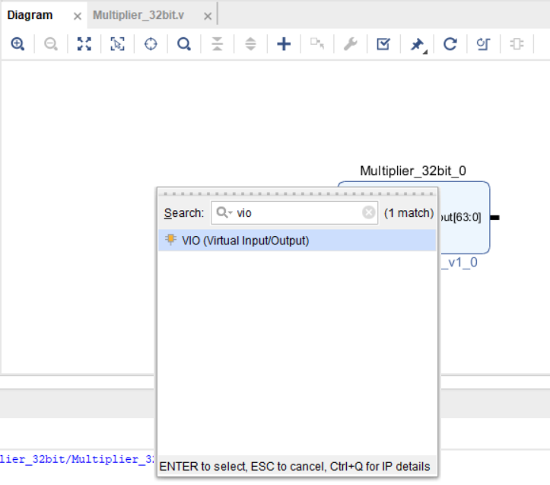

**Step-21**: VIO module is added.

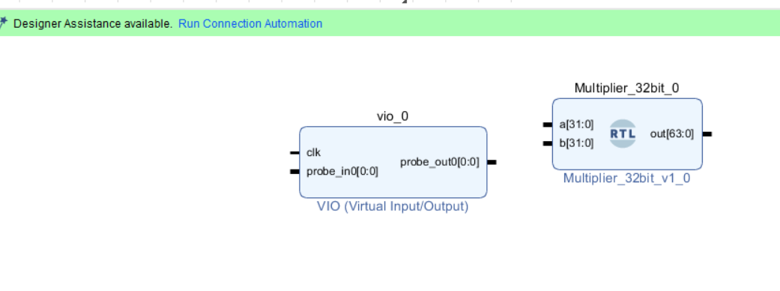

**step-22:** In Diagram block right click, select IP add, then add clocking wizard module. Then it will add in diagram block.

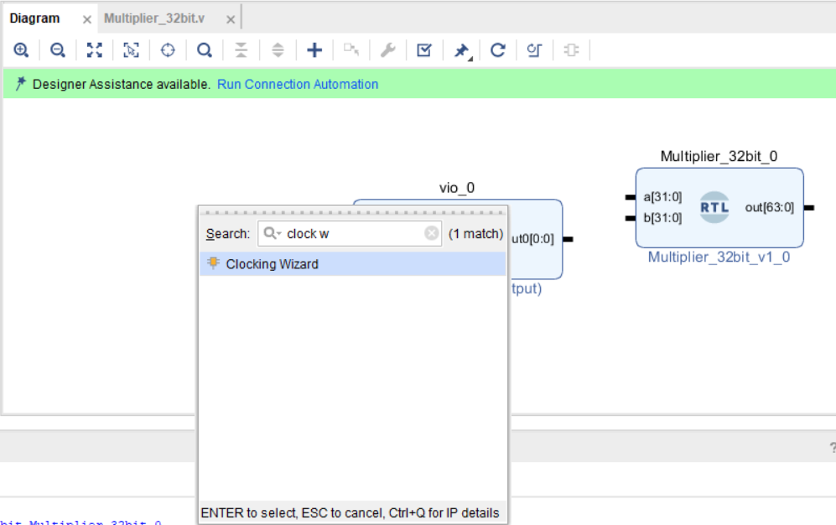

**Step-23:** Double click on VIO in General options, give values Input probe count=1, Output probe count=2.

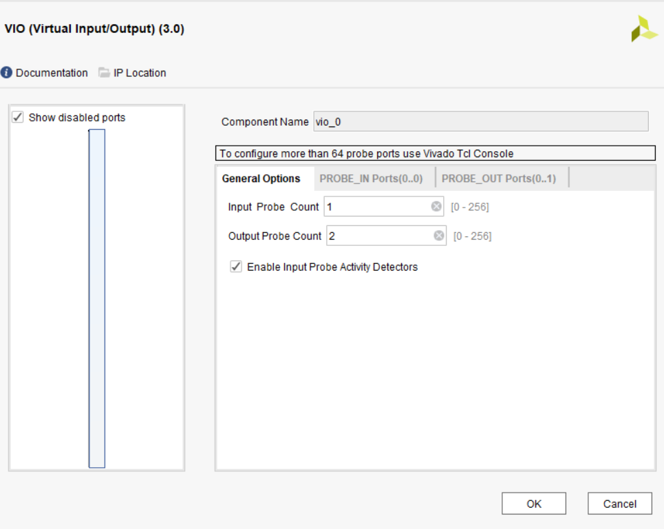

**Step-24:** In probe_inports, give the width=64.

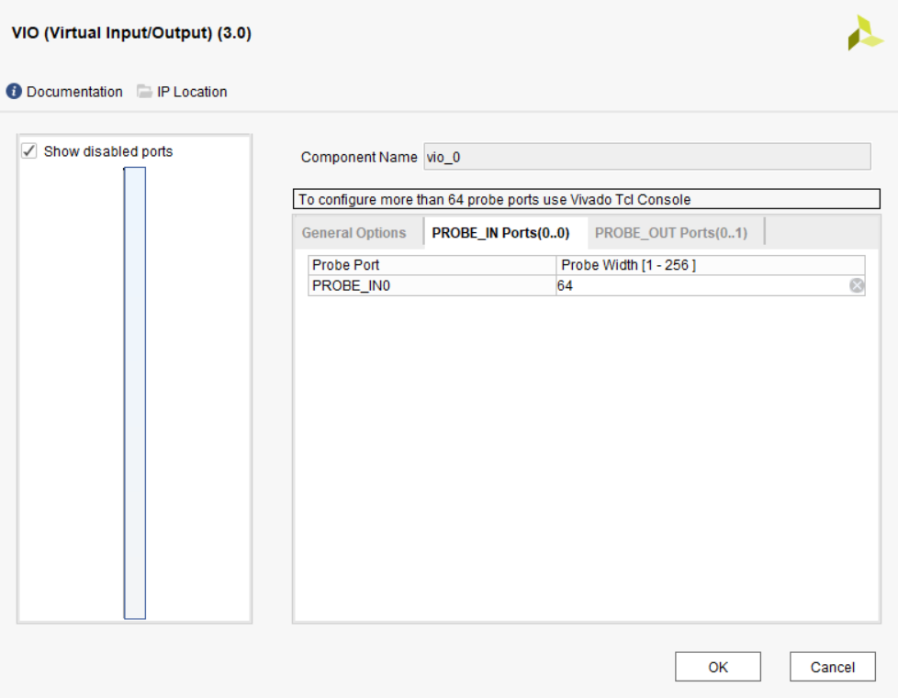

**Step-25:** In probe_out_ports give values, probe_out0=32, probe_out1=32 and then click ok.

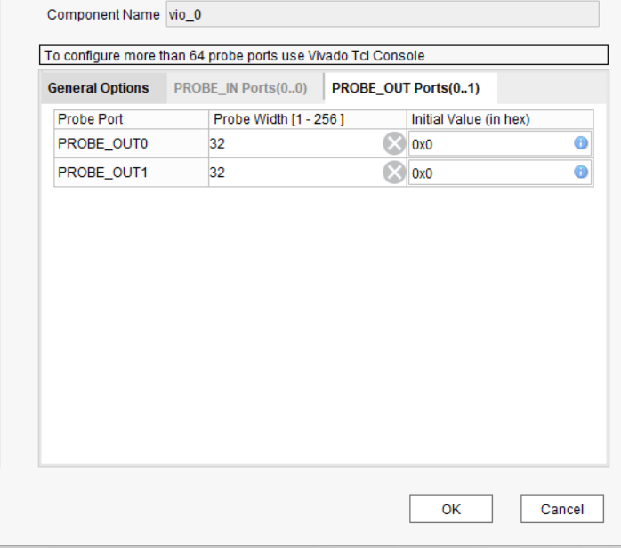

**Step-26:** connect the modules like this. right click on reset make external, and do same process for clk_in1.

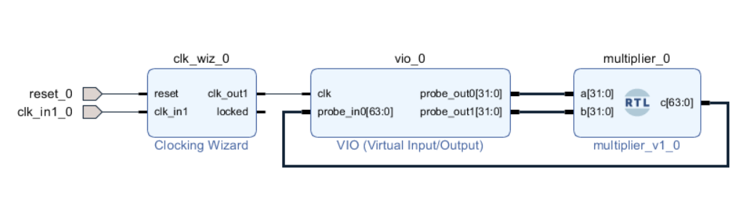

**Step-27:** right click on diagram block, validate the design, click ok.

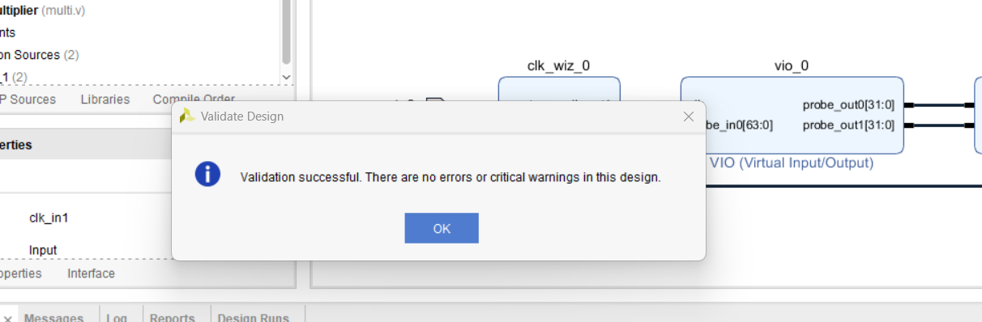

**Step-28:** After validation right click on design_1 block, select create HDL wrapper, click ok.

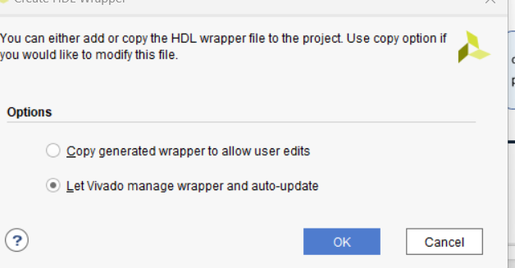

**Step-29:** After generation of HDL wrapper, right click on design_1 block, select the generate output products.

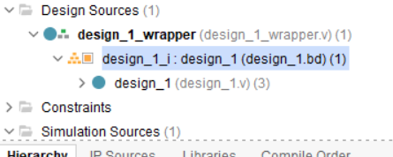

**Step-30:** Click on generate, clock ok.

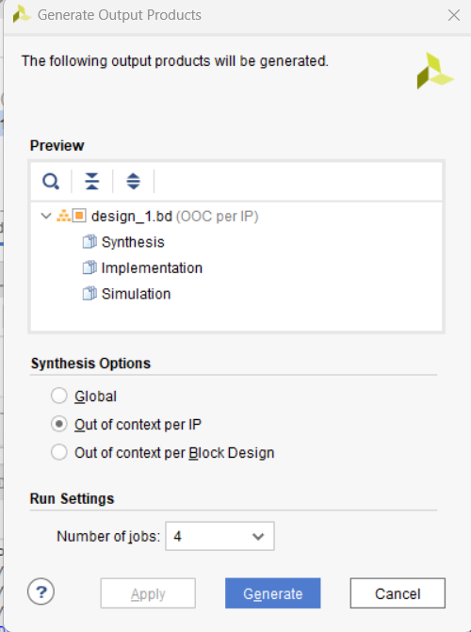

**Step-31:** click on Run synthesis, click ok.



**Step-32:** Right side of corner it will be synthesize.

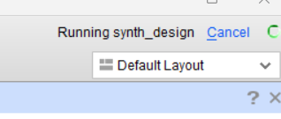

**Step-33:** click on Run implementation, click ok , and click ok again.

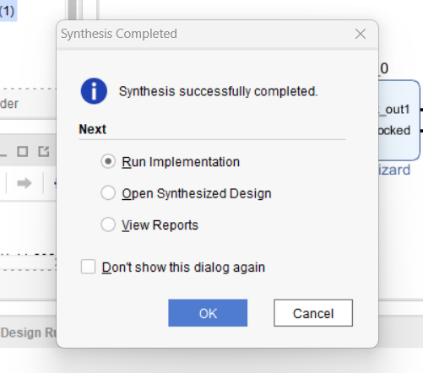

**Step-34** here upside of the right corner the design is implementing.

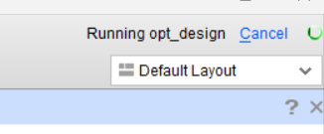

**Step-35:** Click on open implement design.

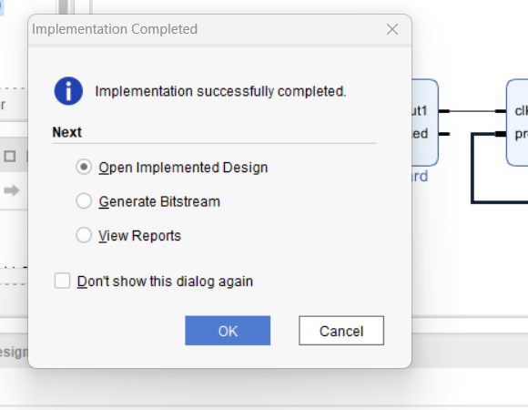

**Step-36:** This is implementation design.

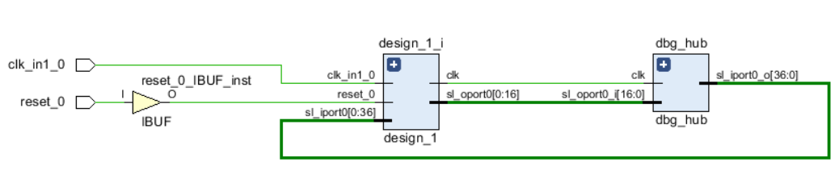

**Step-37**: Now do the pin planning gives pin H16 to clock and D19 to reset.

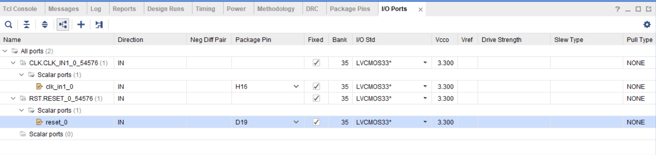

**Step-38:** save the pin plannings. Give file name and choose location to save, click ok.

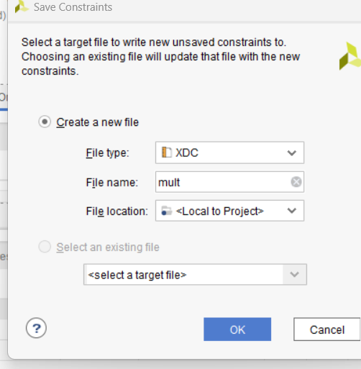

**Step-39:** Here we can see the constraints file. So right click on this file to open.

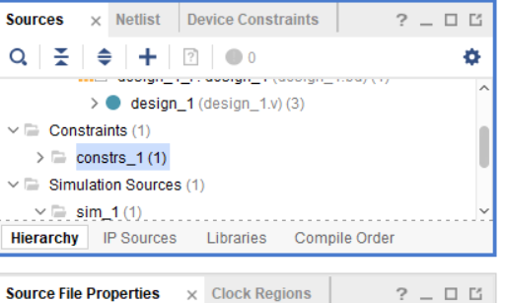

**Step-40:** In this constraints file we can see the pin plannings.

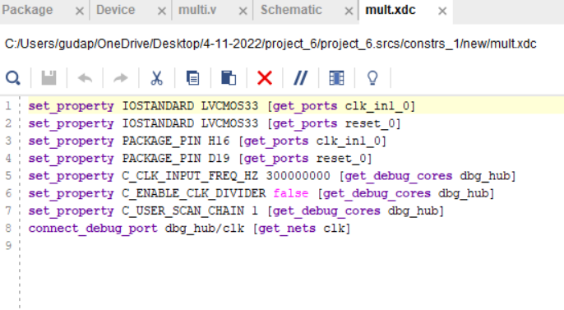

**Step-41:** Now generate the bitstream file.

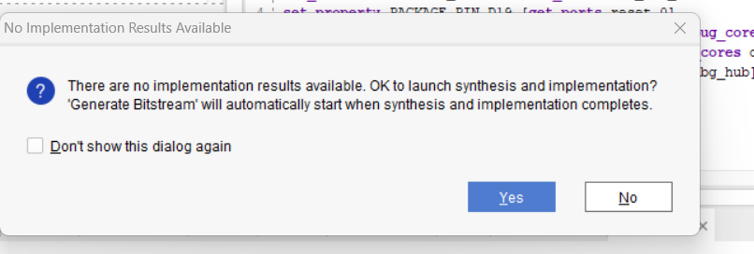

**Step-42:** click ok.

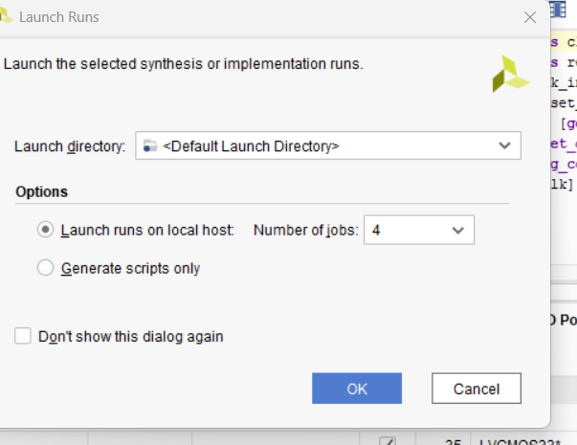

**Step-43:** Open Hardware Manager and click ok.

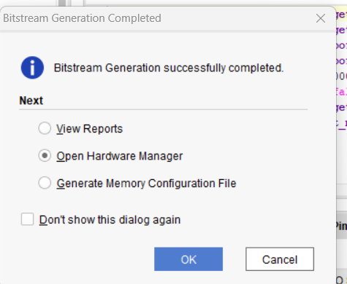

**Step-44:** Now connect the PYNQ-Z2 board to system through USB cable. Click on open target.

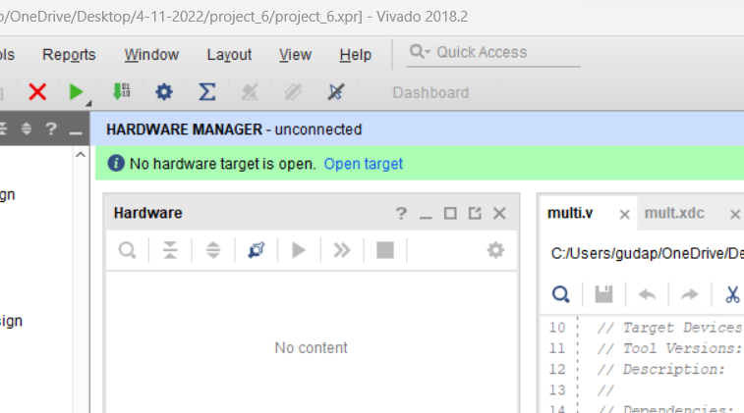

**Step-45:** select the board, dump the program on board and click on program.

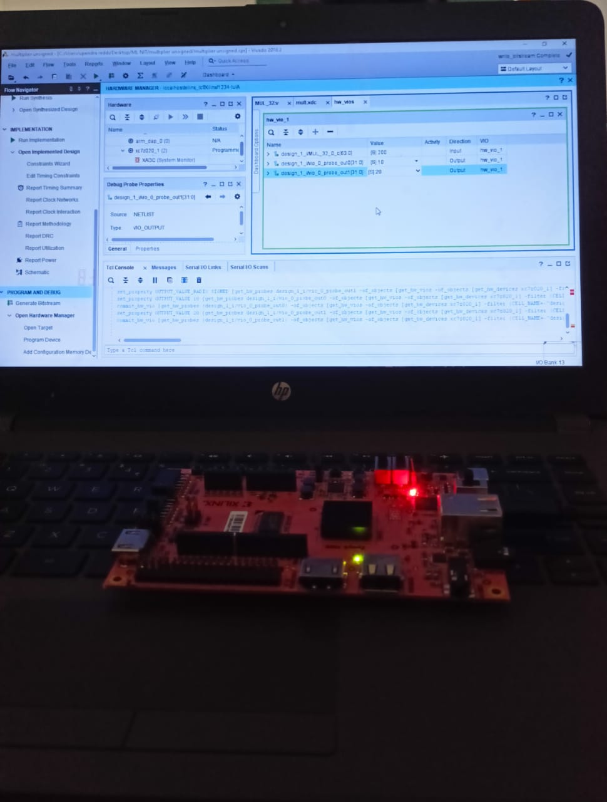

**Step-46:** we multiplied 20 and 10, the output is 200. Here we used IP of multiplier to get the output.